Weekly Meal Plan
Priya@MasalaVegan
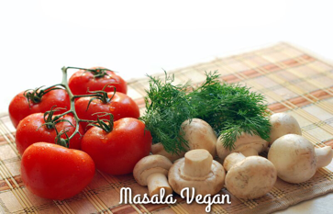

Meal Planner
 | Breakfast | Lunch | Dinner
Monday
Tuesday
Wednesday
Thursday
Friday

